 | Weekly Team Task Report | #1

Team: GeoLearn |  |  |  |  |  | Date: 1/16/2020
Project Title: Improving elementary education with custom online enironmental science lectures

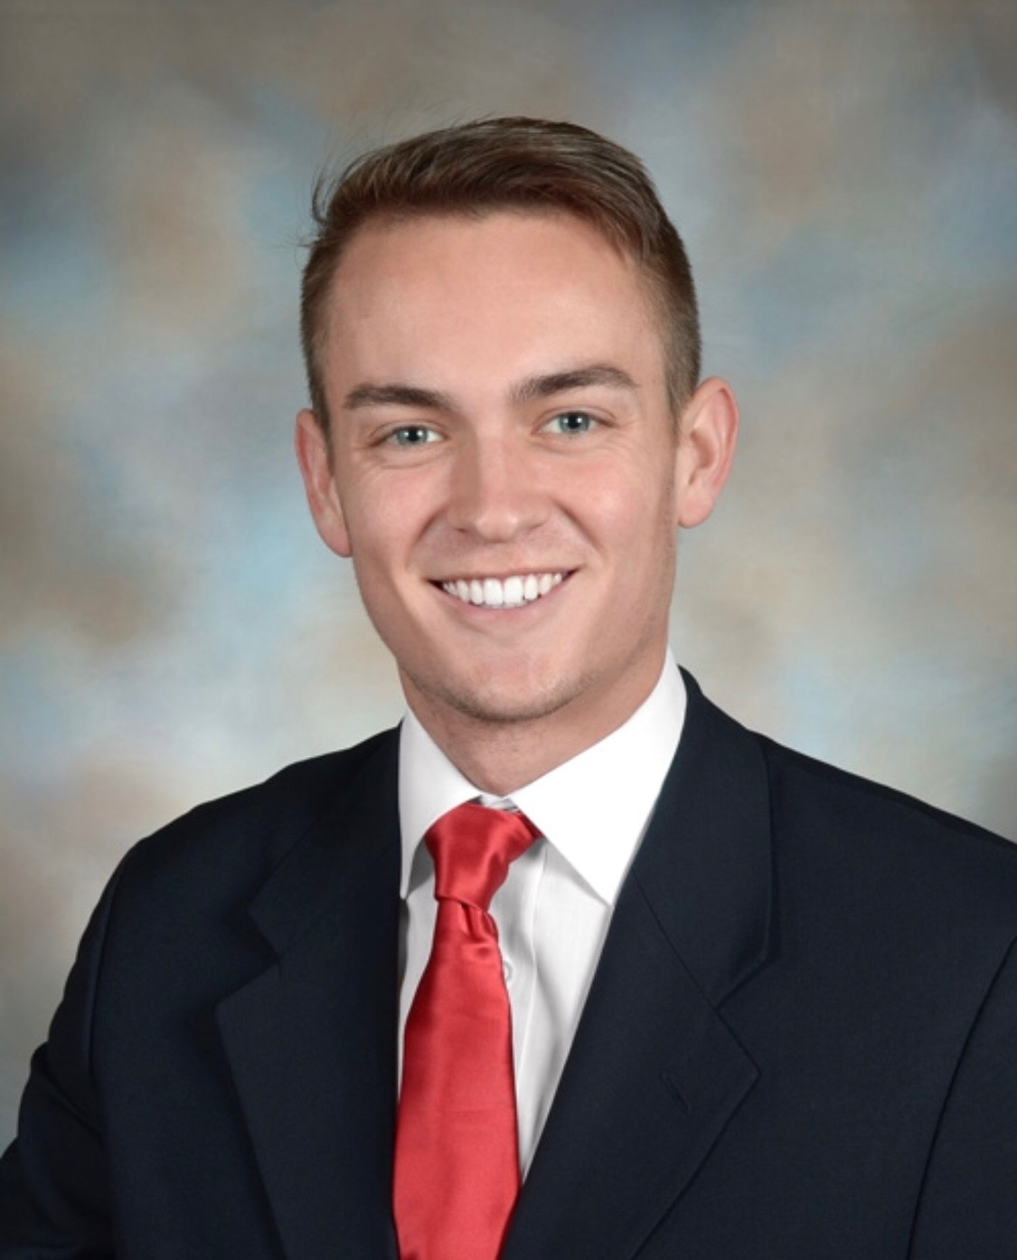 | Samuel Prassse  Present  On-time | 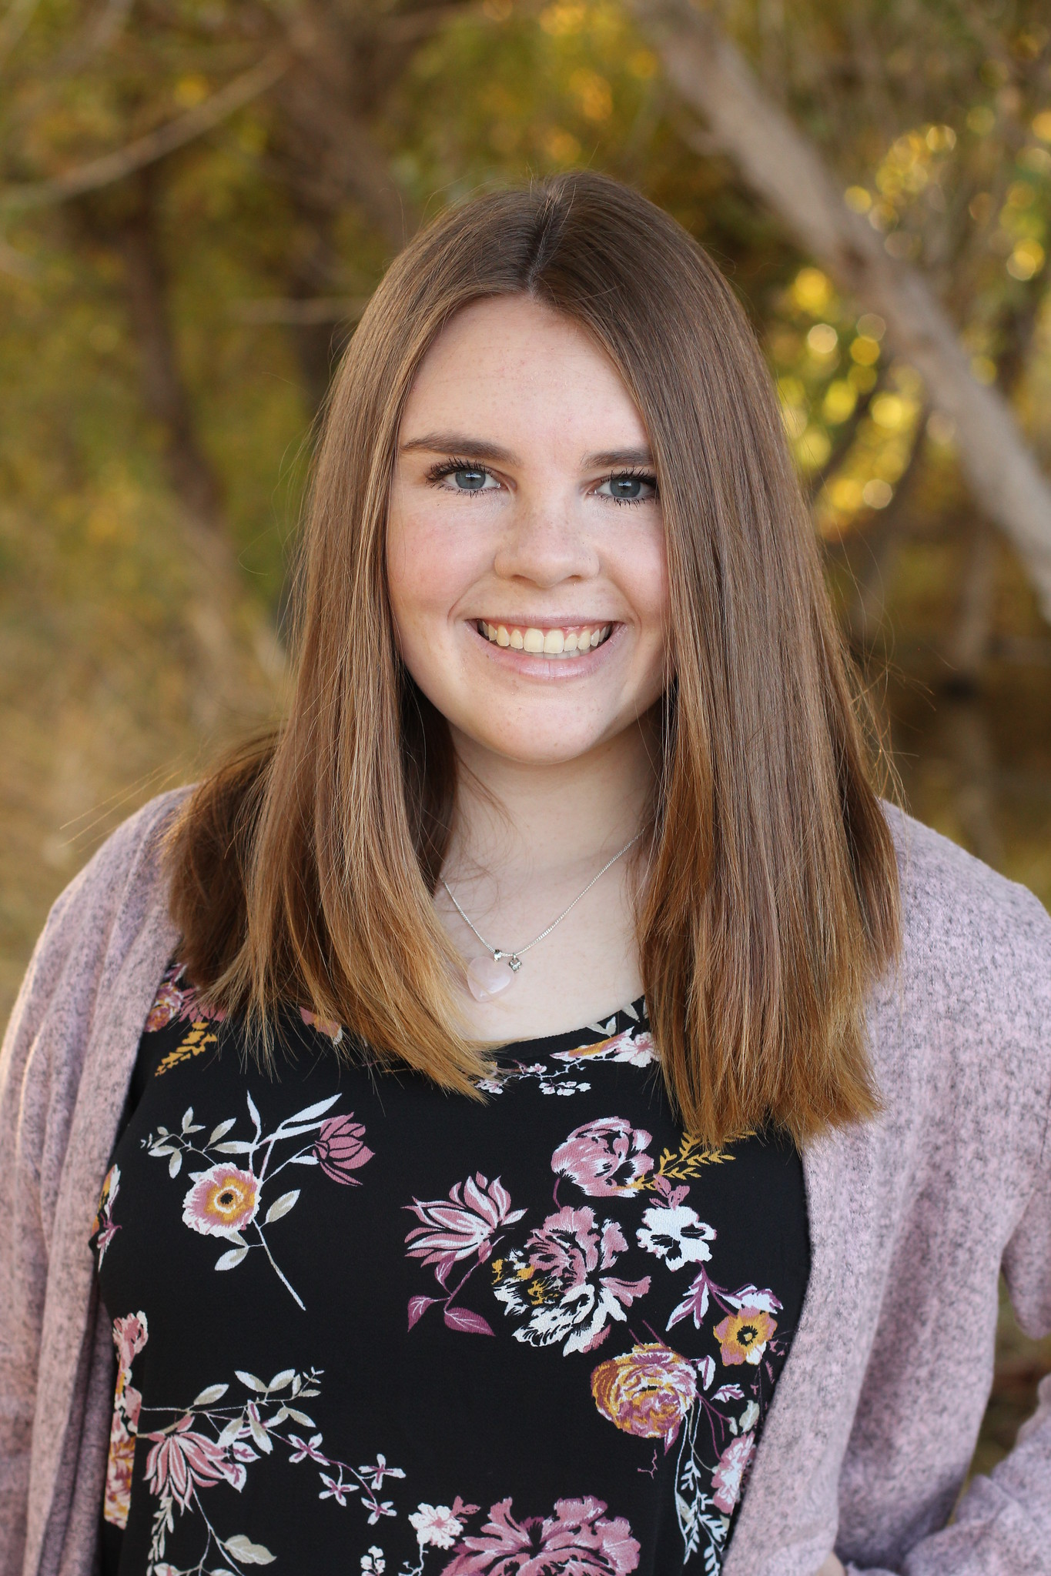 | Kaitlyn Grubb  Present  On-time | 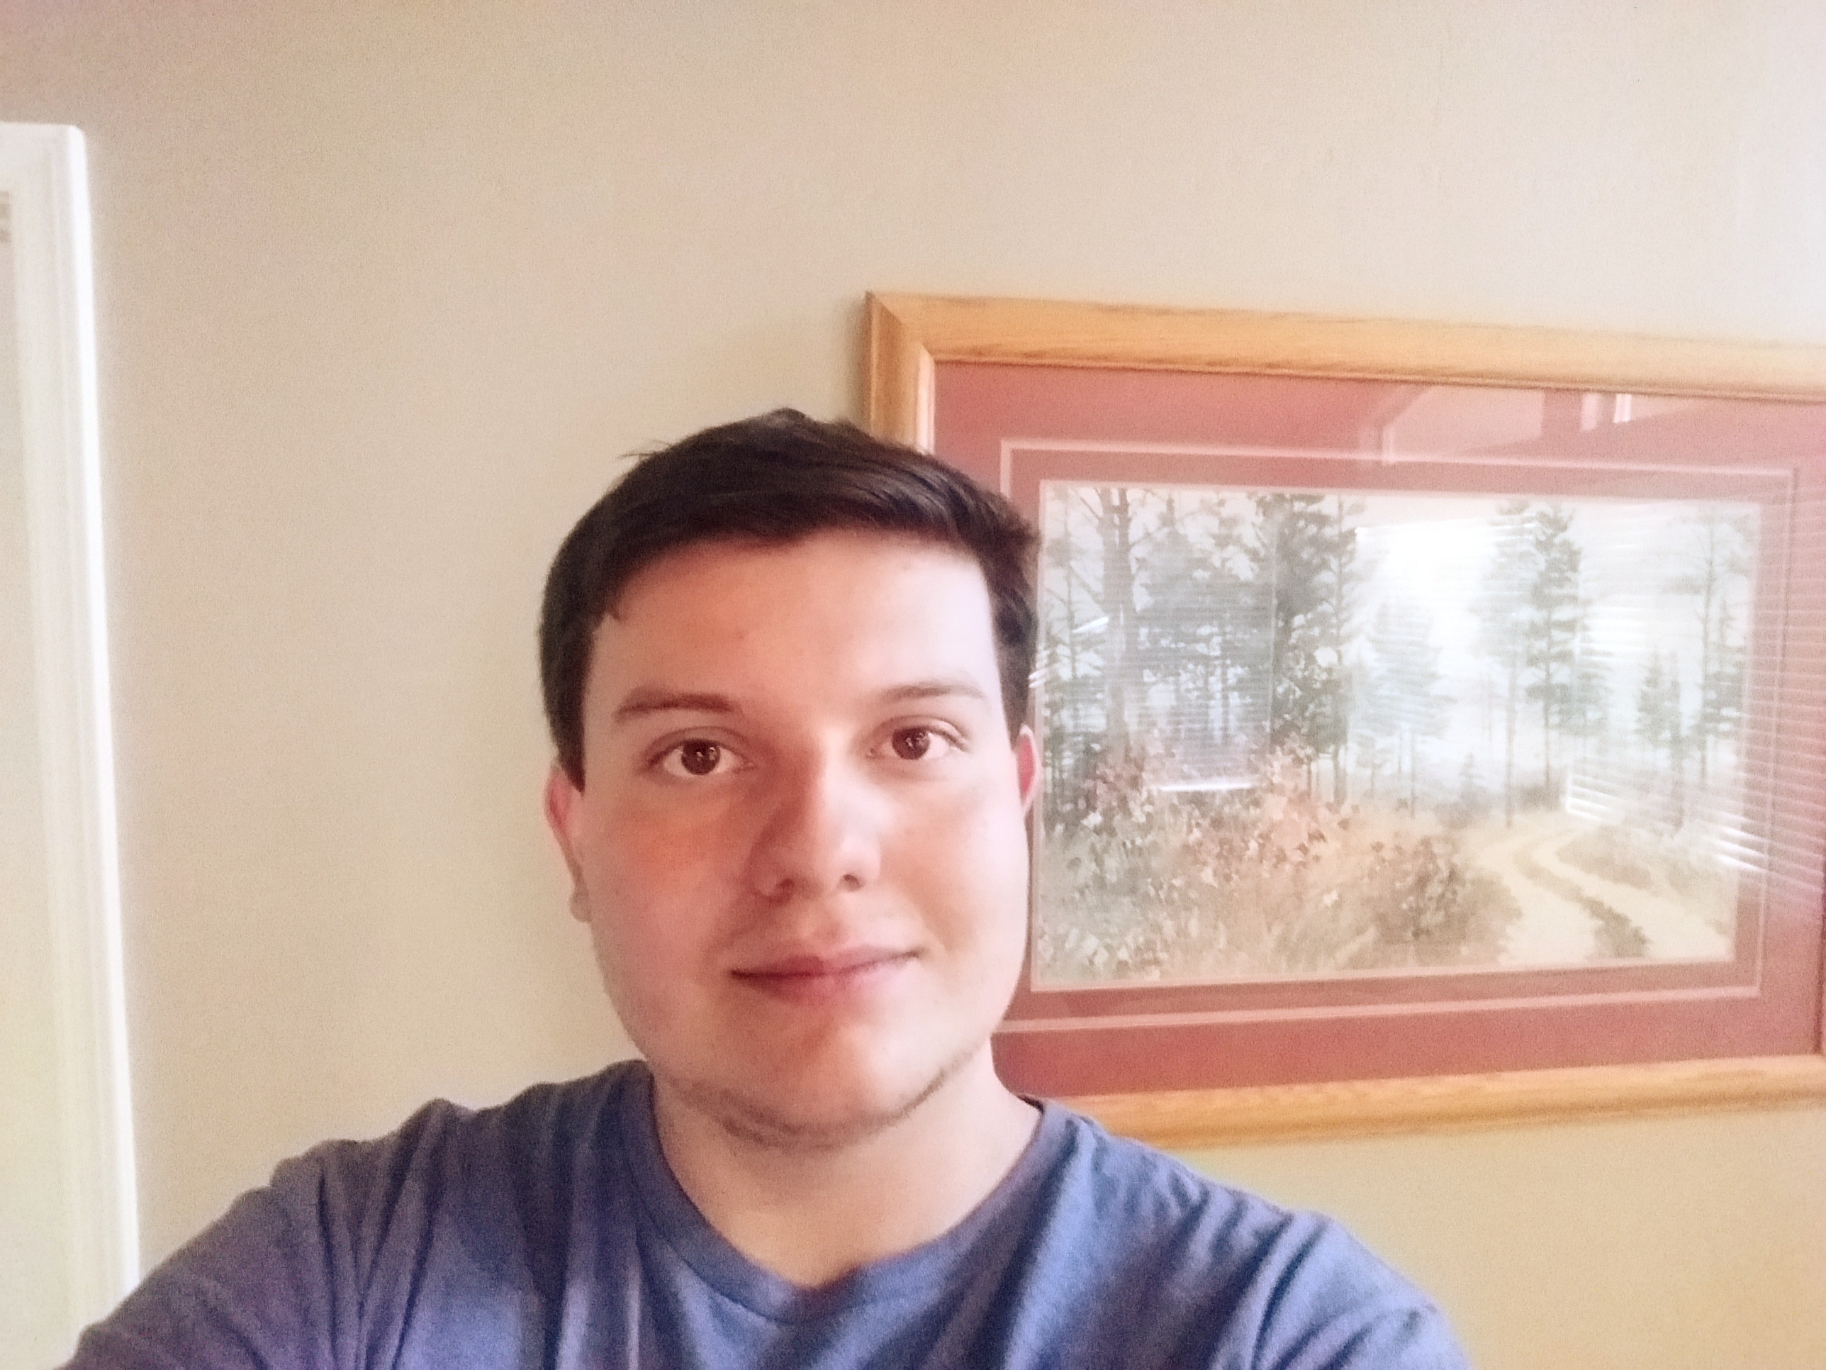 | Tyler Pehringer  Present  On-time |  | 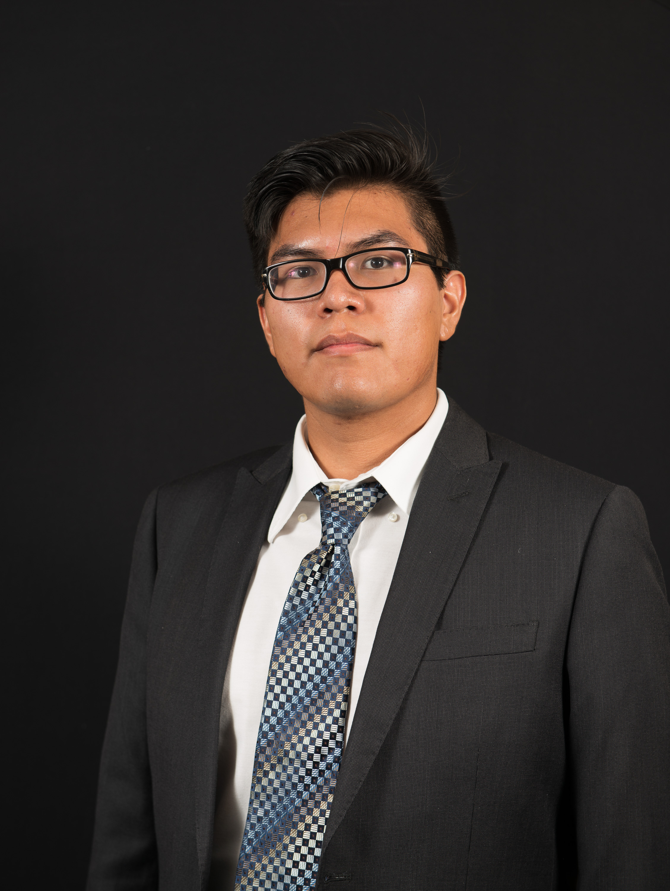 | Joshus Tenakhongva  Present  On-time

Recent Meetings:
- General Team Meeting (Discord)

TASKS COMPLETED since last meeting:

Task Title: Developed a schedule for this semester | Task Initiation: 1/16 | Orig. Due Date: 1/17 | Status: Completed
Who (%): Team (100%)
Description: The team met over Discord to develop a schedule for the semester. It will contain weekly goals of what technologies we want to have implemented.
Expected Outcome: A schedule we can refer to throughout the semester.

This week’s Tasks: Work plan for coming week
Task Title: Combine all parts of project | Task Initiation: 1/16 | Orig. Due Date: 1/24 | Status: In Progress
Who (%): Team (100%)
Description: The team will meet next week after our 2pm mentor meeting to combine all parts of the project as presented in the tech demo. This will give us a good basis to build the rest of the project off of.
Expected Outcome: Have a pieced together project that we can each pull from and work on indicudually.

Task Title: Refine Presentation | Task Initiation: 1/16 | Orig. Due Date: 1/24 | Status: In Progress
Who (%): Team (100%)
Description: The team will meet again next week to refine different parts of the presentation. We felt there were parts that needed to be developed more such as slide information and meaningful graphics, and the information that was spoken in the presentation.
Expected Outcome: We expect to have the cleanest and most well put together presentation out of all the capstone groups.

Upcoming Tasks: Planning
Task Title: Prototype Demo Milestone | Who (%): Team (100%) | Rough Due Date: 3/4
Description: Fully functioning prototype demonstration.

Other Problems / Other Issues:
- Discuss presentation techniques and graphics
- Get server and database from Dr. Doughty
- Discuss images with Dr. Doughty

